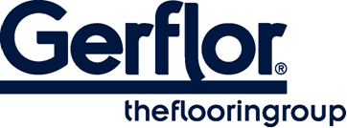 MURAL CALYPSO

MURAL CALYPSO is a multilayered wall covering in 2m width roll and with a B-s2,d0 fire classification.

It is hot welded with CR40 welding rods. It will ensure a perfect water tightness.
This wallcovering is particularly recommended for use in wet room areas and will make installation in angles easy.
It is part of the Taradouche “shower” System which is compliant with regulation regarding access for disabled people.

It is made of a printed transparent wear layer and a coloured under layer for an easier welding of the product. This layer comprises up to 30% recycled products.

According to ISO 22196, MURAL CALYPSO has anti-bacterial activity against E. coli, S. aureus and MRSA of 99% after 24h00.

It does not contain any CMR 1 & 2 component and is 100% compliant with REACH.
It is 100% recyclable.

